**Unveiling the Virtual Classroom: An In-depth Analysis of the Online Education System**

**DEFINE PROBLEM / PROBLEM UNDERSTANDING**

The main challenge of a virtual classroom is keeping students focused. Unlike a traditional classroom, teachers cannot walk around the room to supervise students. As most of the children can get easily distracted, they will not be able to grasp what the teacher is teaching online.

* **SPECIFY THE BUSINESS PROBLEM**
* Online classes and technology have emerged as a superhero during the lockdown days. We have all been under house arrest but are still connected with the world of education. Due to the lockdown, students have not been able to stay connected with the outer world and the lack of exposure is evident. The only reprieve for the students’ mental well-being has been the transition to online classes. Teachers made sure that the learning for students was not compromised, so they took a great leap forward to find solutions and create new learning environments for their students to ensure that learning never stops. With the rapid advancements in technology and the widespread availability of internet access, online education has gained significant popularity in recentyears.  
   **BUSINESS REQUIREMENTS & LITERATURE SURVEY**
* In December 2019, an outbreak of a novel coronavirus, known as COVID-19, occurred in China and has spread rapidly across the globe within a few months. COVID-19 is an infectious disease caused by a new strain of coronavirus that attacks the respiratory system (World Health Organization, [2020](https://www.ncbi.nlm.nih.gov/pmc/articles/PMC8162157/#CR47)).
* As of January 2021, COVID-19 has infected 94 million people and has caused 2 million deaths in 191 countries and territories (John Hopkins University, [2021](https://www.ncbi.nlm.nih.gov/pmc/articles/PMC8162157/#CR26)). This pandemic has created a massive disruption of the educational systems, affecting over 1.5 billion students. It has forced the government to cancel national examinations and the schools to temporarily close, cease face-to-face instruction, and strictly observe physical distancing. These events have sparked the digital transformation of higher education and challenged its ability to respond promptly and effectively. Schools adopted relevant technologies, prepared learning and staff resources, set systems and infrastructure, established new teaching protocols, and adjusted their curricula.
* However, the transition was smooth for some schools but rough for others, particularly those from developing countries with limited infrastructure (Pham & Nguyen, [2020](https://www.ncbi.nlm.nih.gov/pmc/articles/PMC8162157/#CR32); Simbulan, [2020](https://www.ncbi.nlm.nih.gov/pmc/articles/PMC8162157/#CR37)).Inevitably, schools and other learning spaces were forced to migrate to full online learning as the world continues the battle to control the vicious spread of the virus.
* Online learning refers to a learning environment that uses the Internet and other technological devices and tools for synchronous and asynchronous instructional delivery and management of academic programs (Usher & Barak, [2020](https://www.ncbi.nlm.nih.gov/pmc/articles/PMC8162157/#CR44); Huang, [2019](https://www.ncbi.nlm.nih.gov/pmc/articles/PMC8162157/#CR25)).
* Synchronous online learning involves real-time interactions between the teacher and the students, while asynchronous online learning occurs without a strict schedule for different students (Singh & Thurman, [2019](https://www.ncbi.nlm.nih.gov/pmc/articles/PMC8162157/#CR39)).
* Within the context of the COVID-19 pandemic, online learning has taken the status of interim remote teaching that serves as a response to an exigency.
* However, the migration to a new learning space has faced several major concerns relating to policy, pedagogy, logistics, socioeconomic factors, technology, and psychosocial factors (Donitsa-Schmidt &Ramot, [2020](https://www.ncbi.nlm.nih.gov/pmc/articles/PMC8162157/#CR17); Khalil et al., [2020](https://www.ncbi.nlm.nih.gov/pmc/articles/PMC8162157/#CR29); Varea& González-Calvo, [2020](https://www.ncbi.nlm.nih.gov/pmc/articles/PMC8162157/#CR45)).
* With reference to policies, government education agencies and schools scrambled to create fool-proof policies on governance structure, teacher management, and student management.
* Teachers, who were used to conventional teaching delivery, were also obliged to embrace technology despite their lack of technological literacy. To address this problem, online learning webinars and peer support systems were launched.
* On the part of the students, dropout rates increased due to economic, psychological, and academic reasons. Academically, although it is virtually possible for students to learn anything online, learning may perhaps be less than optimal, especially in courses that require face-to-face contact and direct interactions (Franchi, [2020](https://www.ncbi.nlm.nih.gov/pmc/articles/PMC8162157/#CR21)).
* **SOCIAL OR BUSINESS IMPACT.**

**PROS OF E-LEARNING:**

* The availability of recorded lectures allows the learners to rewatch the content.
* No need to commute to any institution.
* We can access the courses from anywhere.
* It allows a flexible schedule where one can learn at a time of their convenience.
* E-learning promotes a habit of self-paced learning.

**CONS OF E-LEARNING:-**

* It demands heavy self-discipline from the learner such that they can sit and attend their online classes.
* E-learning is not accessible to everyone.
* Not everyone has the same access to computers and the internet, which is required for attending online learning.
* E-learning is not inclusive, as many individuals need special or one on one attention from a mentor to understand the course matter.
* It does not give the users any networking opportunities.

**DATA COLLECTION**

Collect the dataset & Connect data with IBM cognos

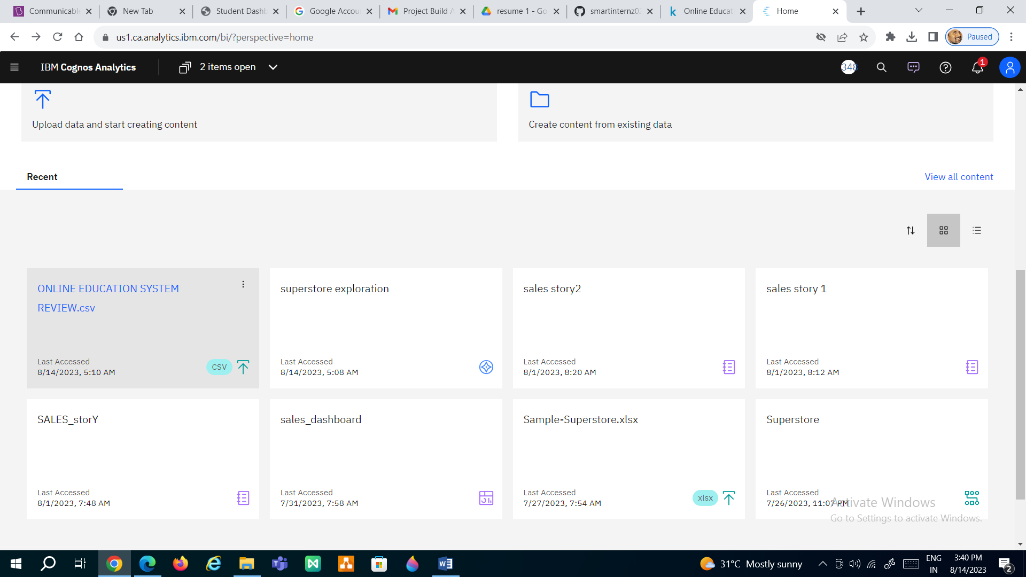

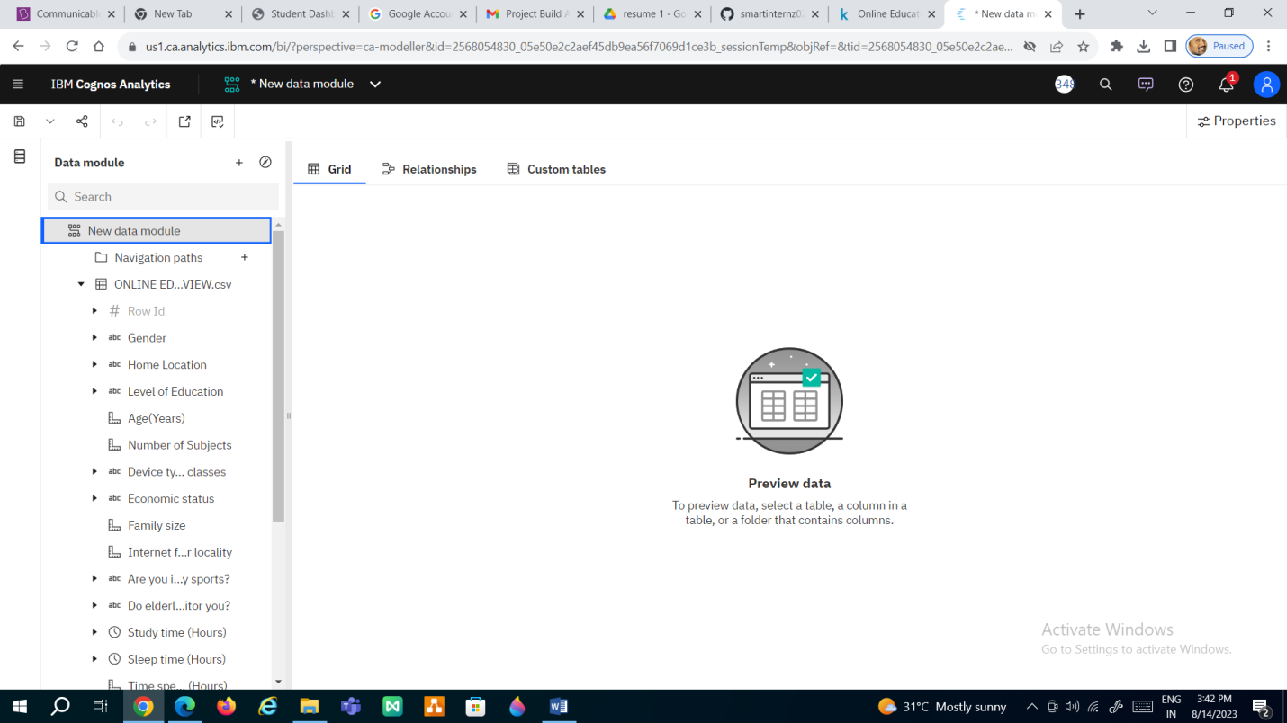

**DATA PREPARATION**

Prepare the Data for Visualization

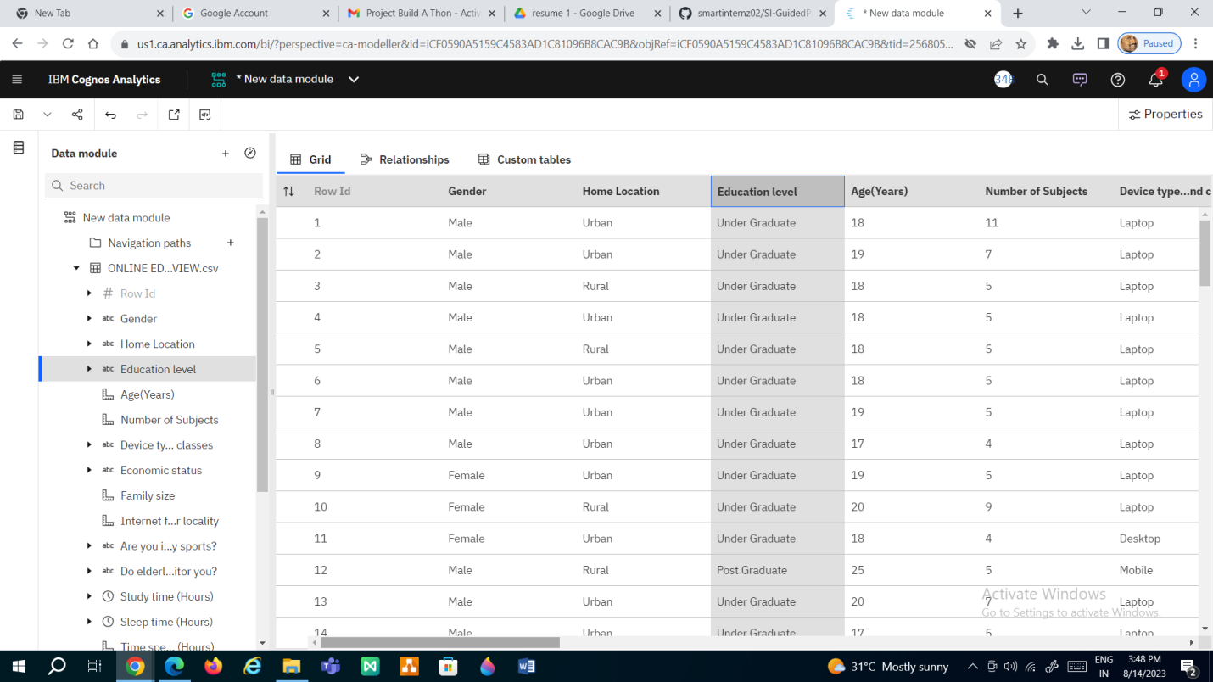

**DATA VISUALIZATIONS**

No of Unique Visualizations

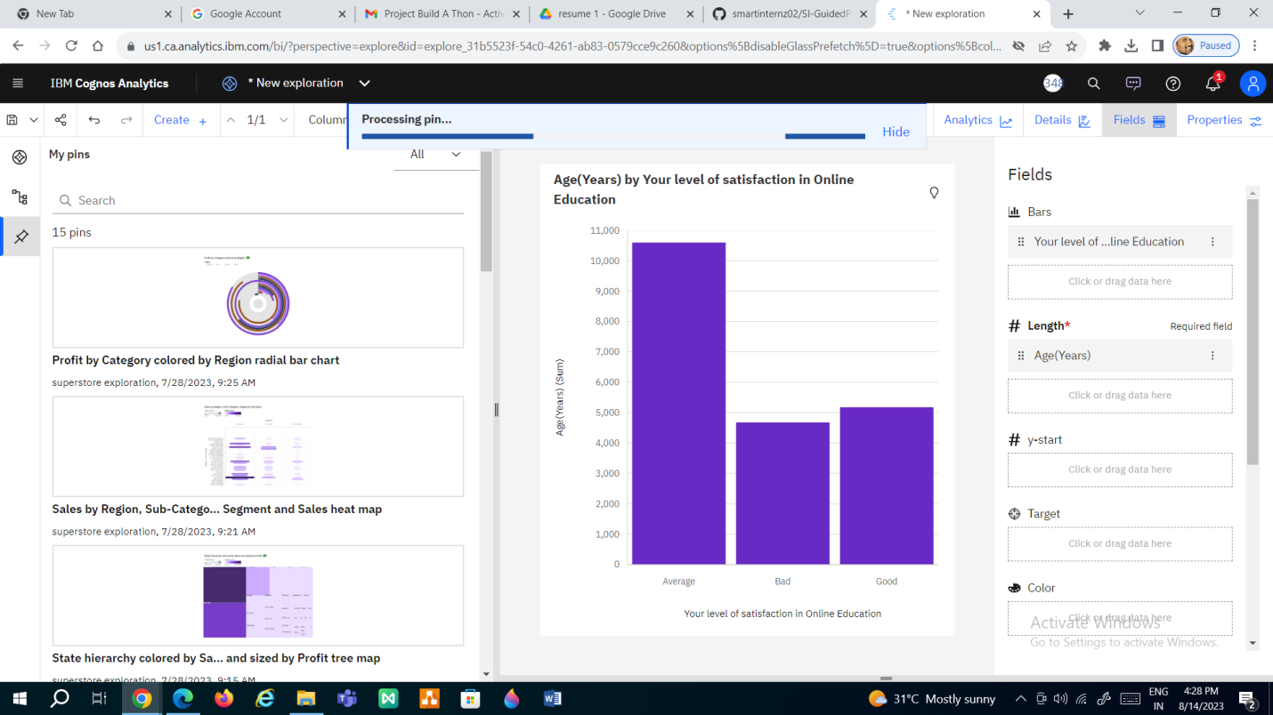

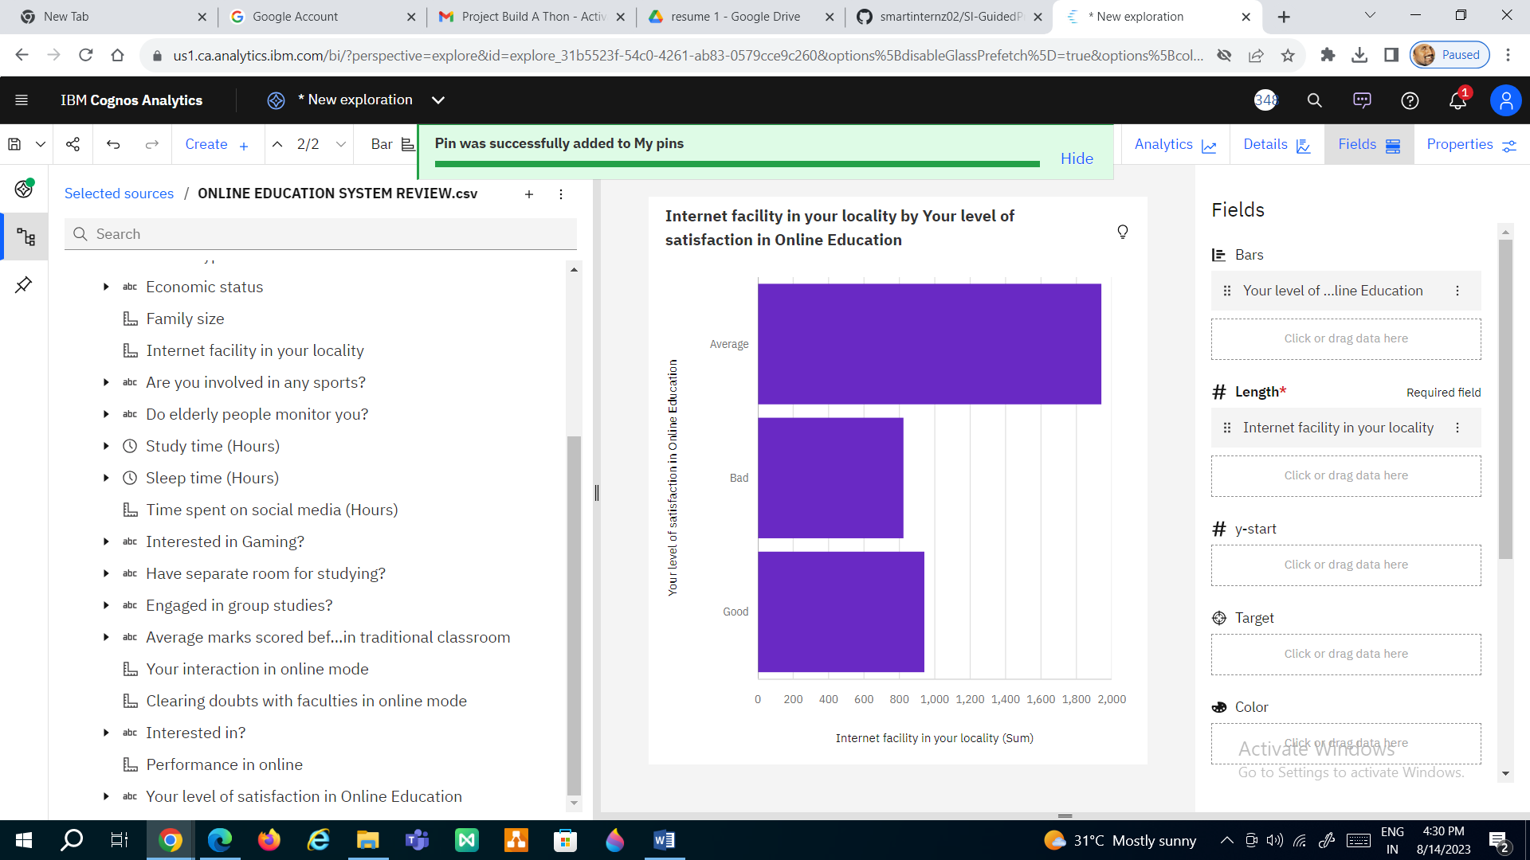

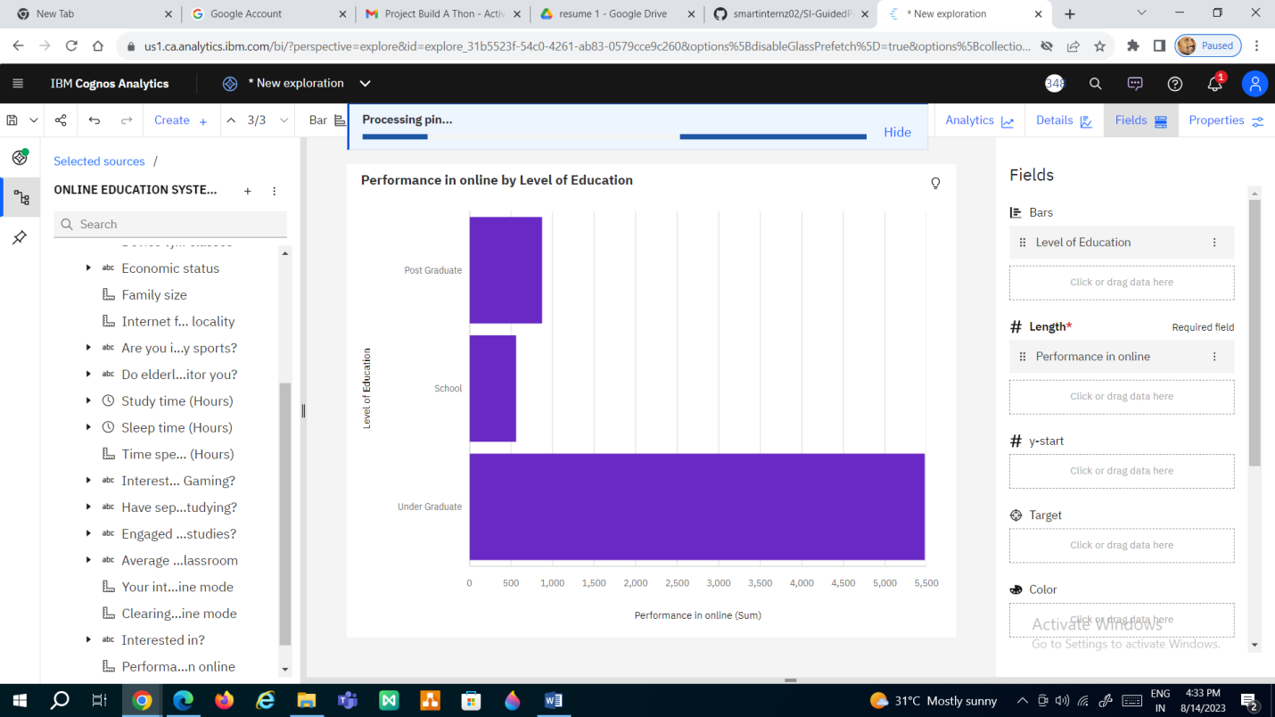

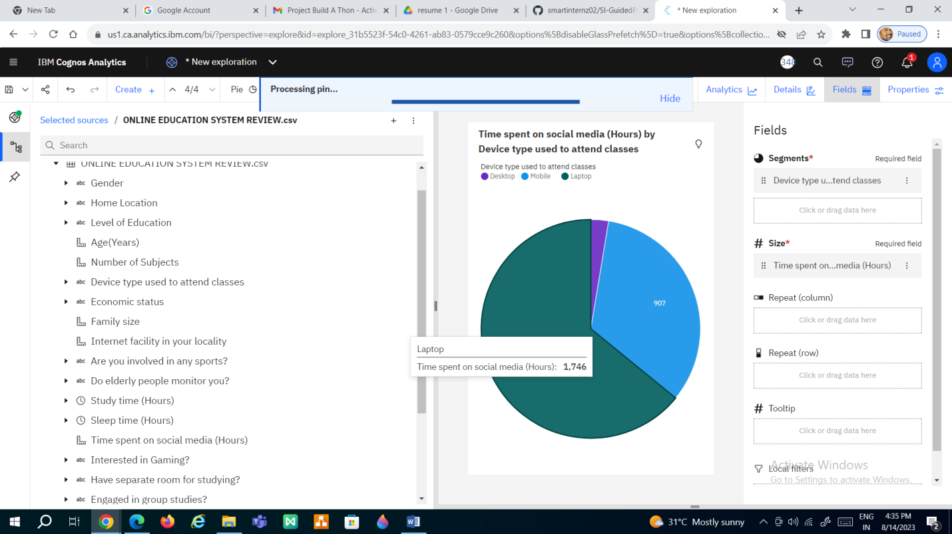

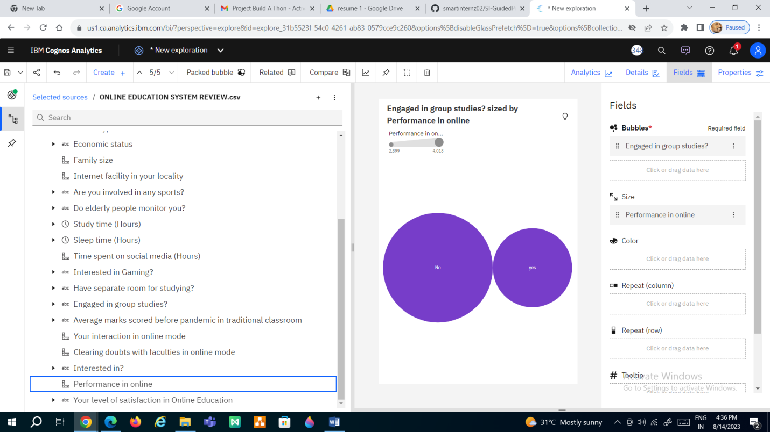

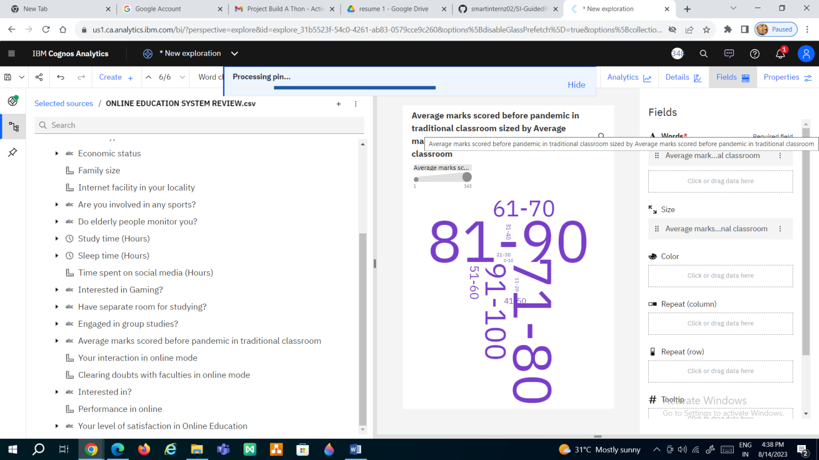

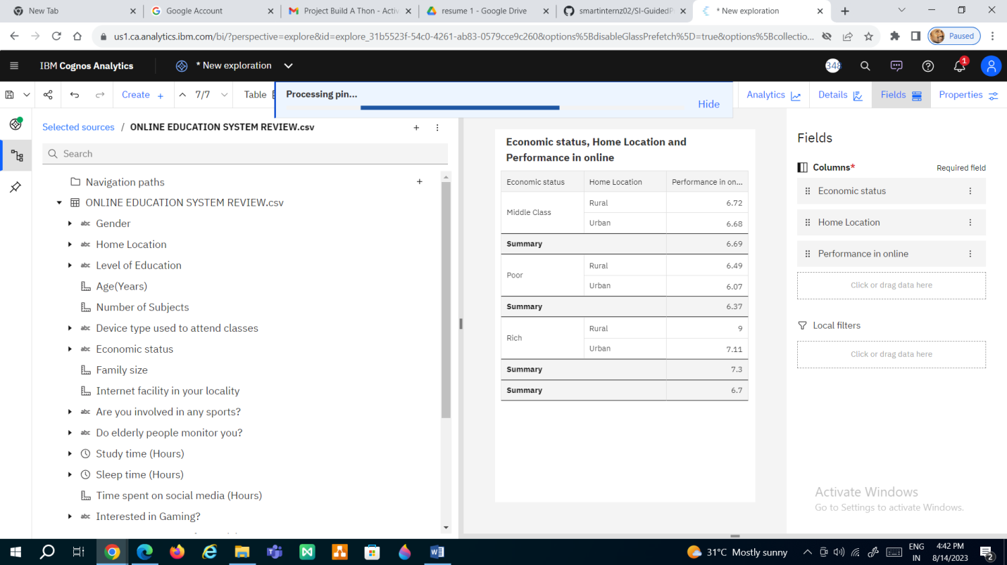

**DASHBOARD**

* + Responsive and Design of Dashboard &No of Scenes of Story

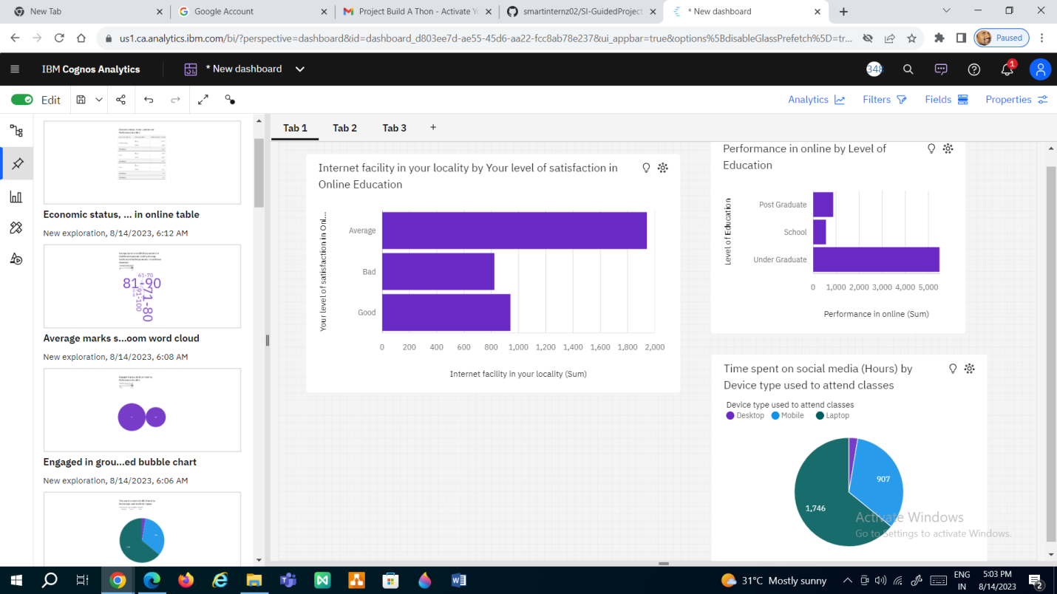

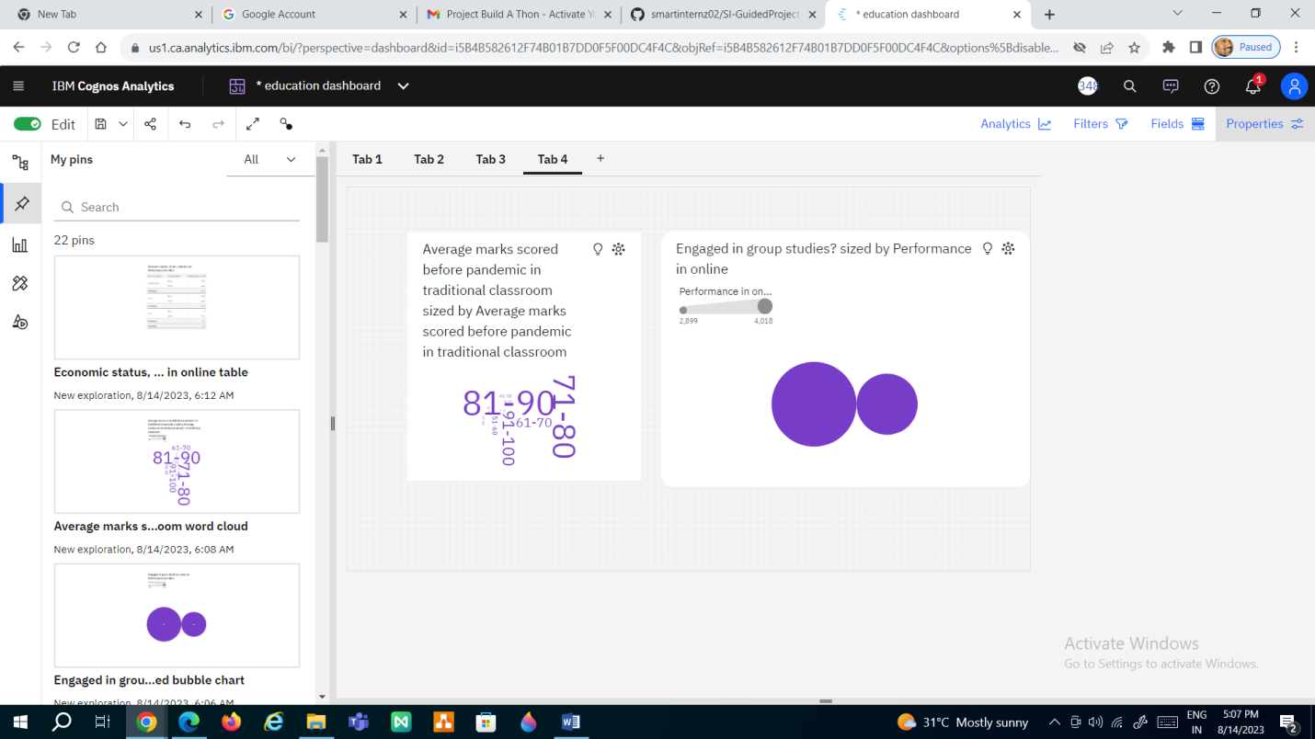

**STORY**

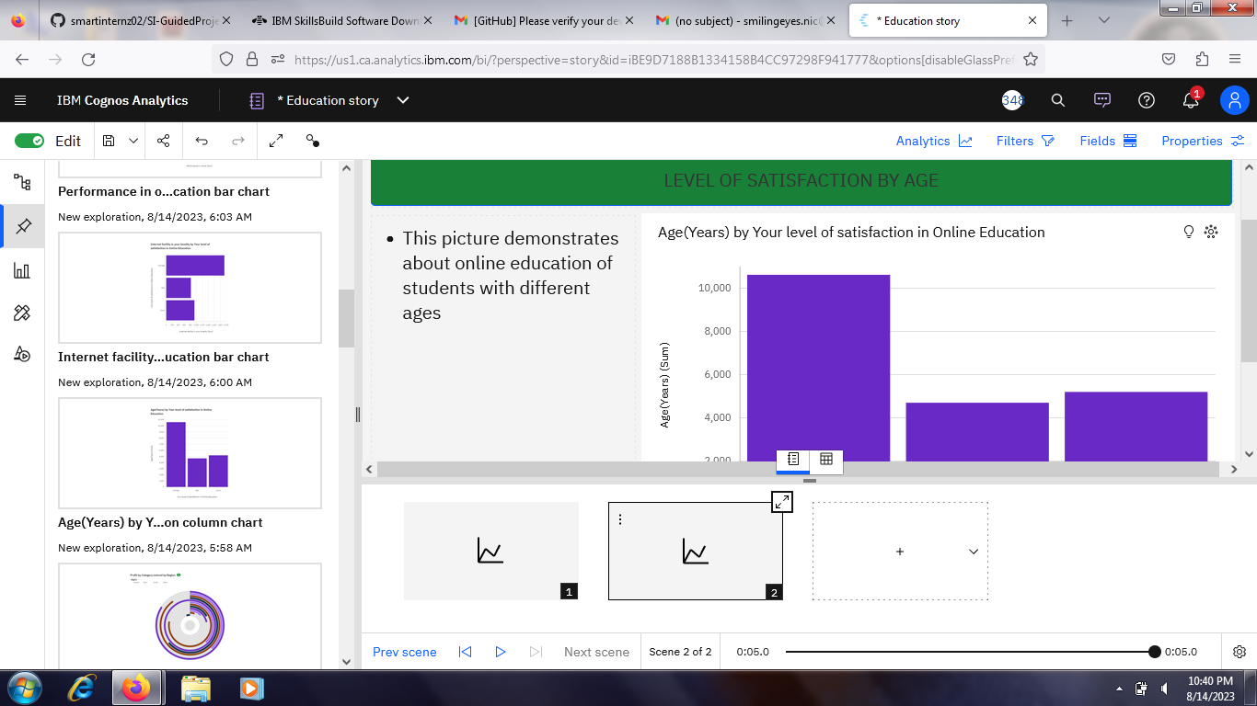

**REPORT**

Creating a report



**PERFORMANCE TESTING**

Utilization of Data Filters

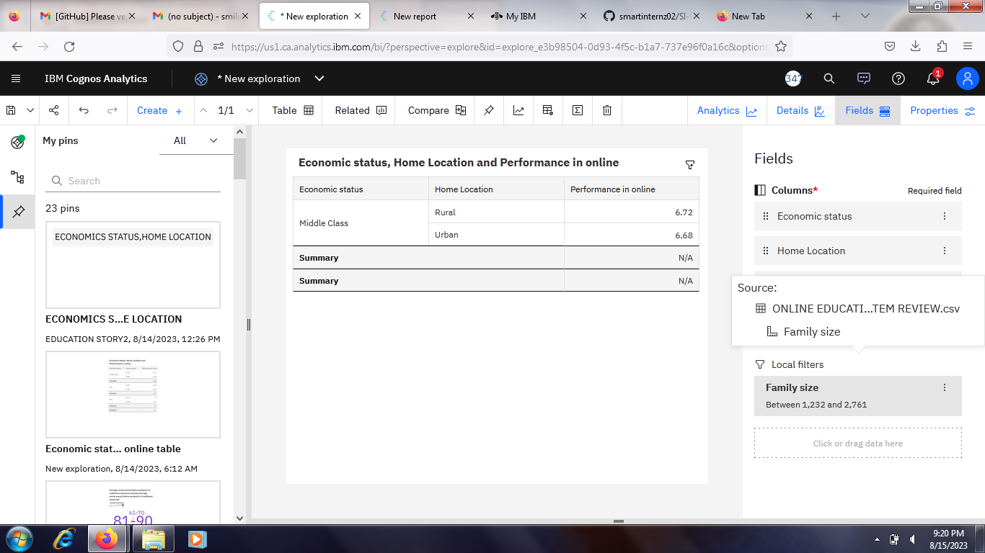

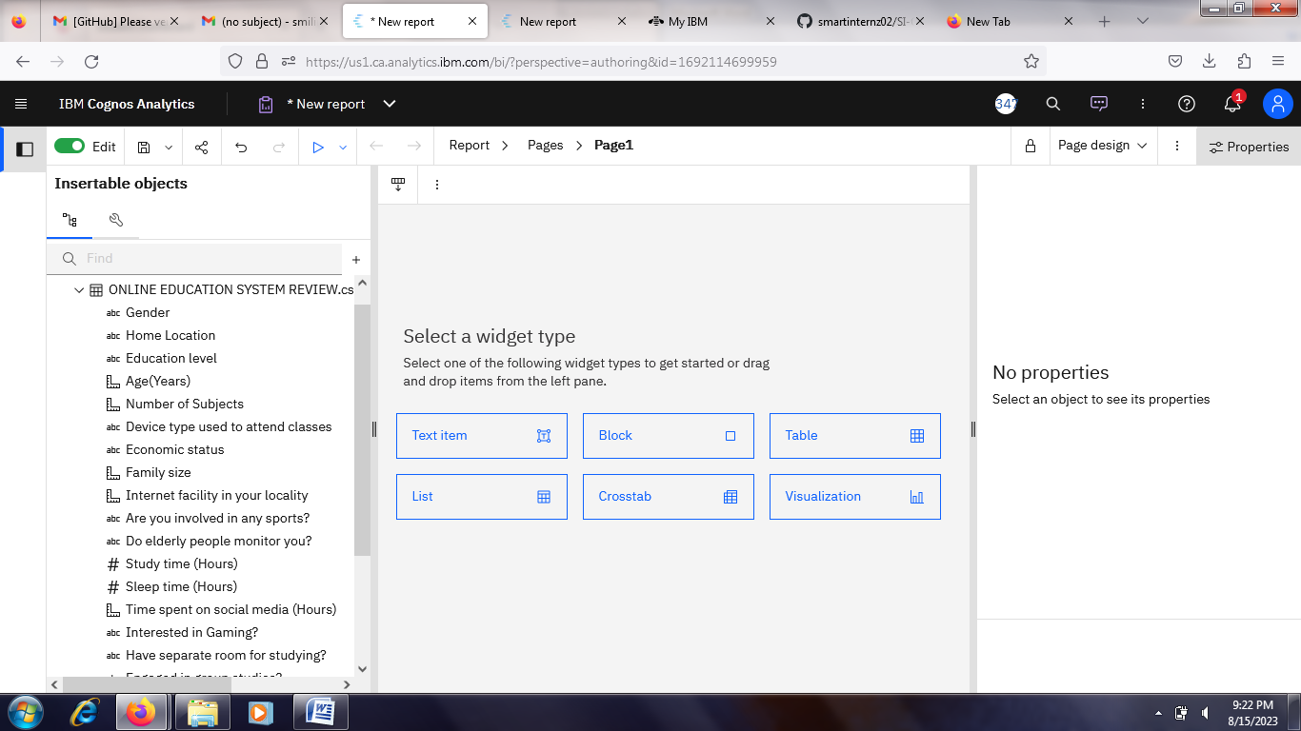

**WEB INTEGRATION**

Dashboard and Story embed with UI With Flask

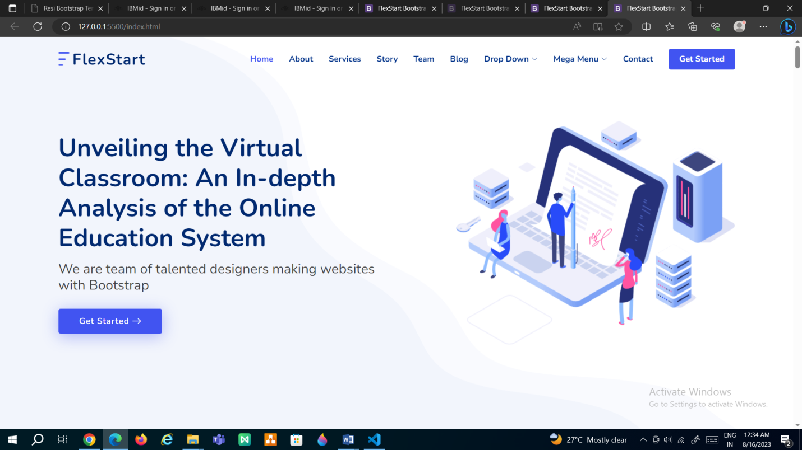

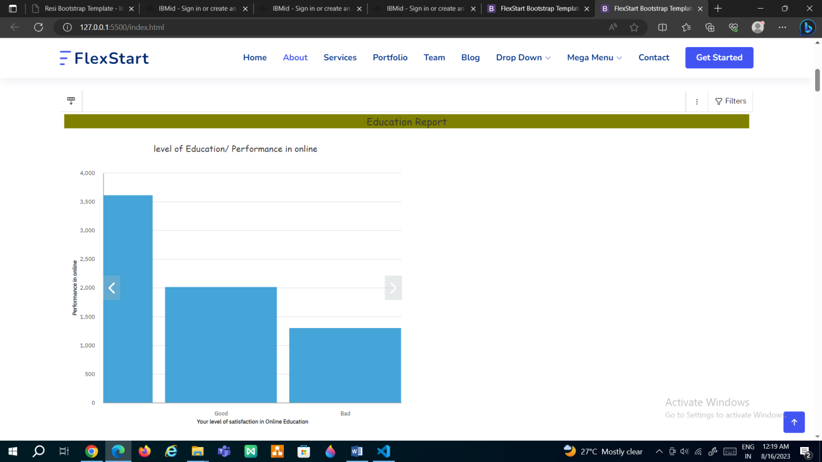

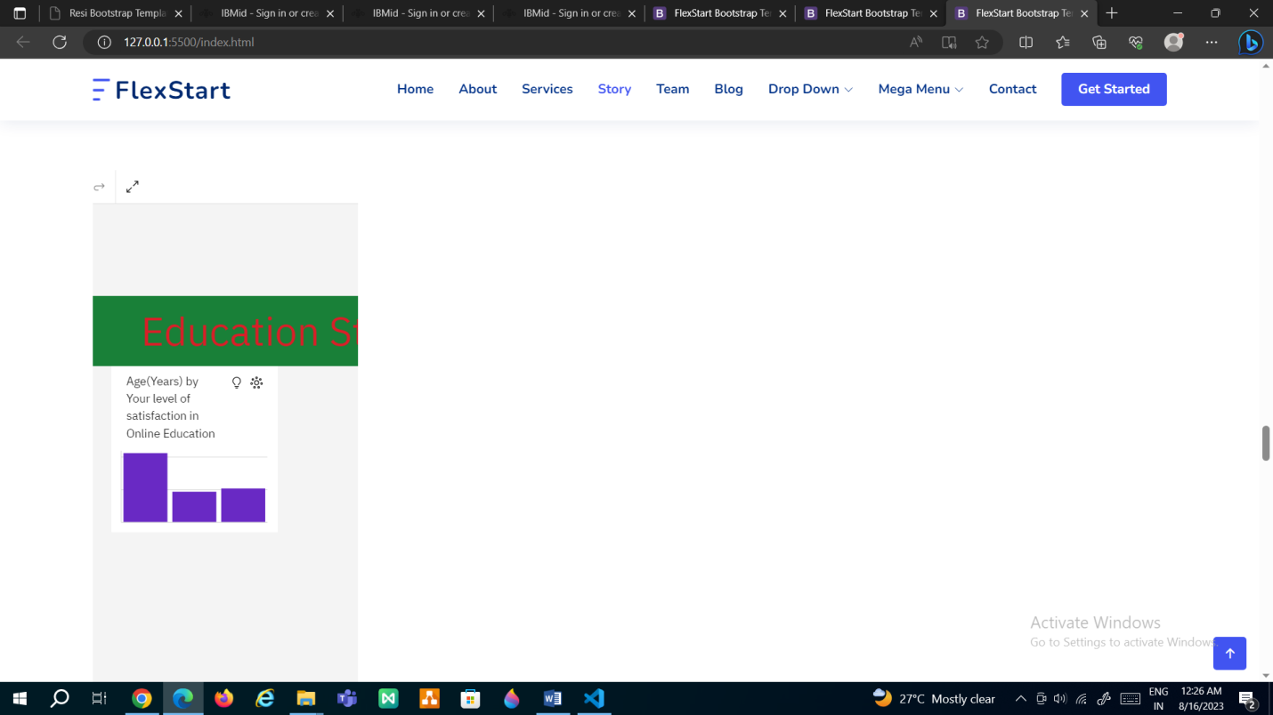

**COURSES COMLPETED**







